INTRODUCTION TO CLOUD COMPUTING
Lab Task 02 (A) (Manage Subscriptions and RBAC)

Name: Arshia M Ali
ID: 2280140
Section: BSSE 7B

Task 1: Implement Management Groups
Create a management group:
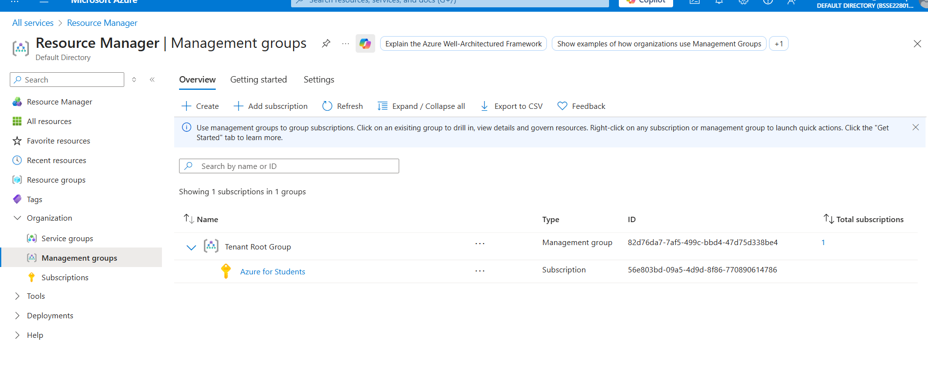
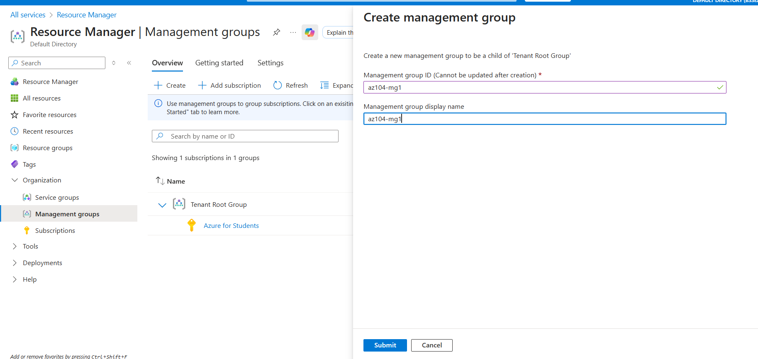

Management group created successfully:
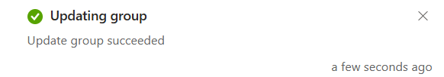
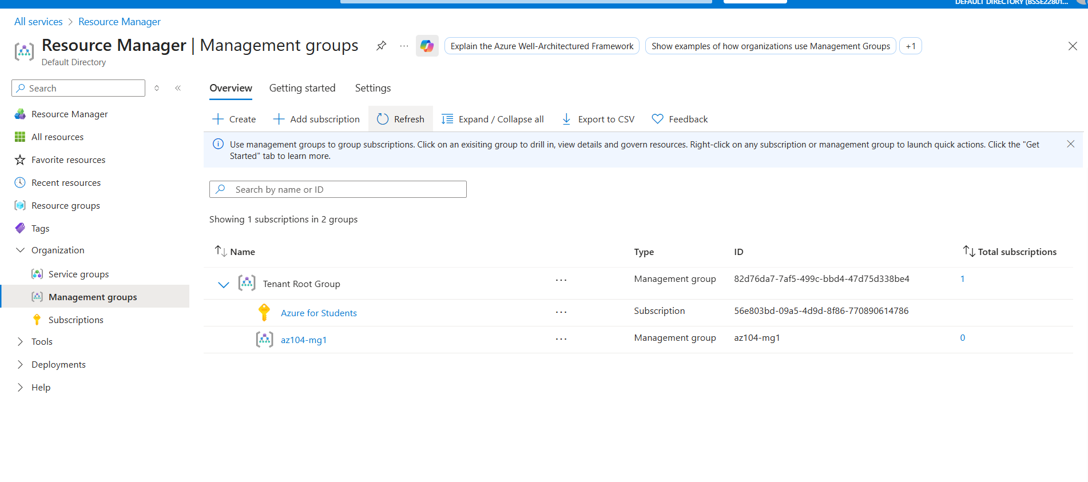

Task 2: Review and Assign a Built-in Azure Role
Created a Helpdesk group:
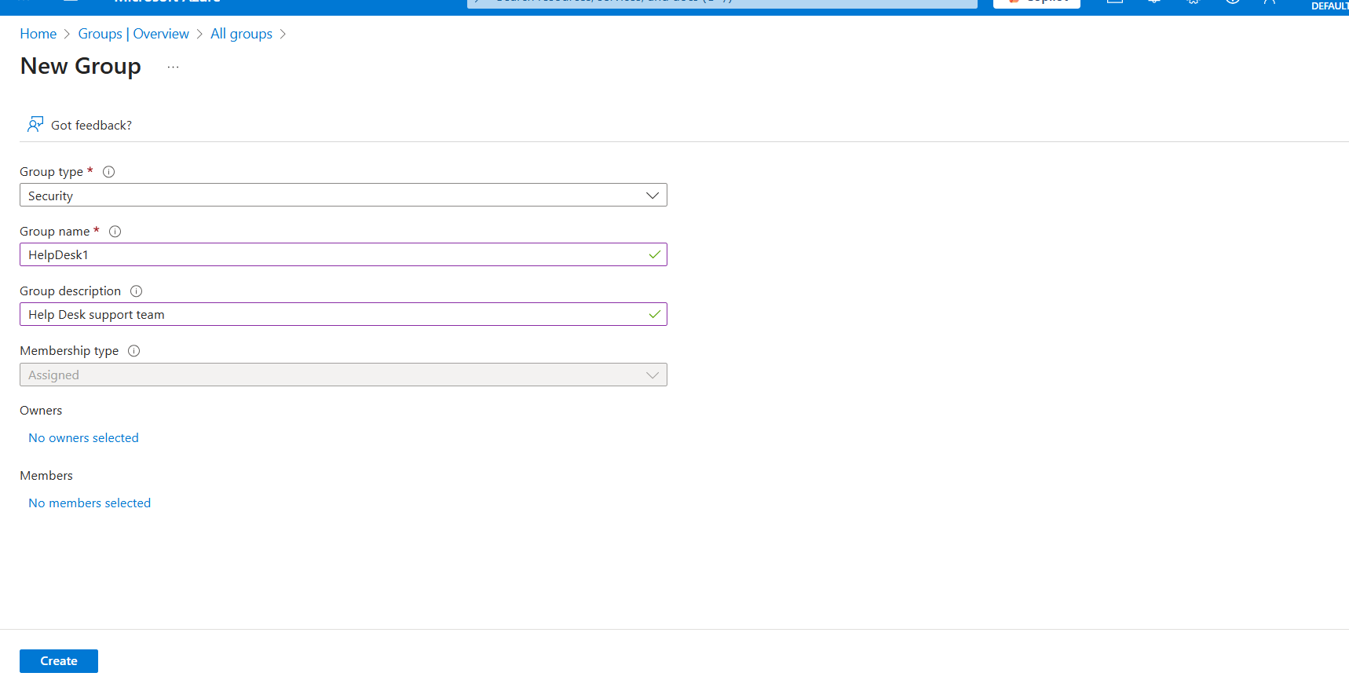

Assign the VMC role to the helpdesk group:
Open the az104-mg1 management group
Go to Access control (IAM) and open the Roles tab
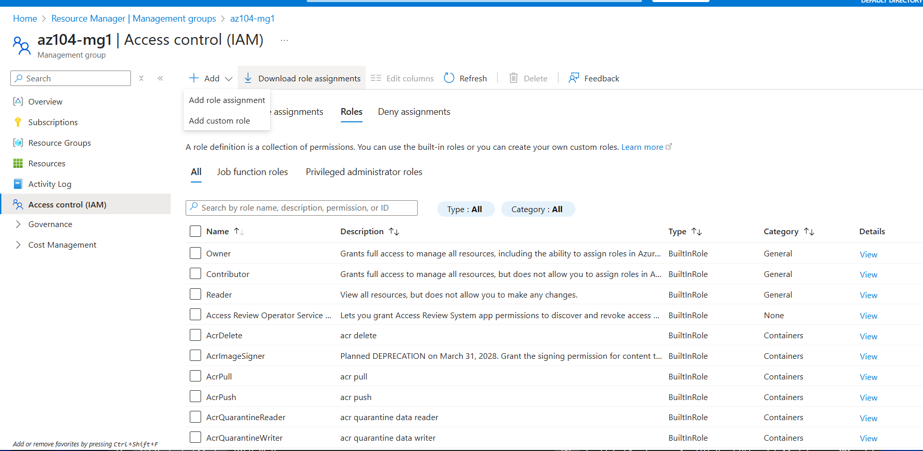

Add role assignment.
Choose the Virtual Machine Contributor role.
Add the helpdesk group as the member
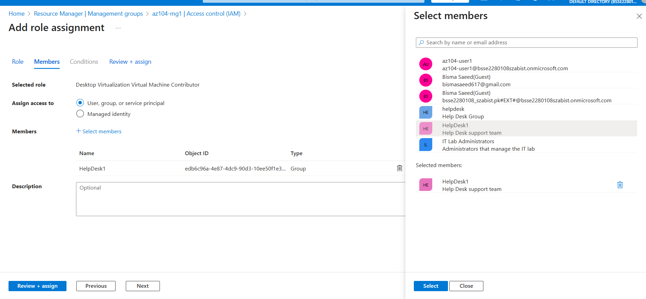
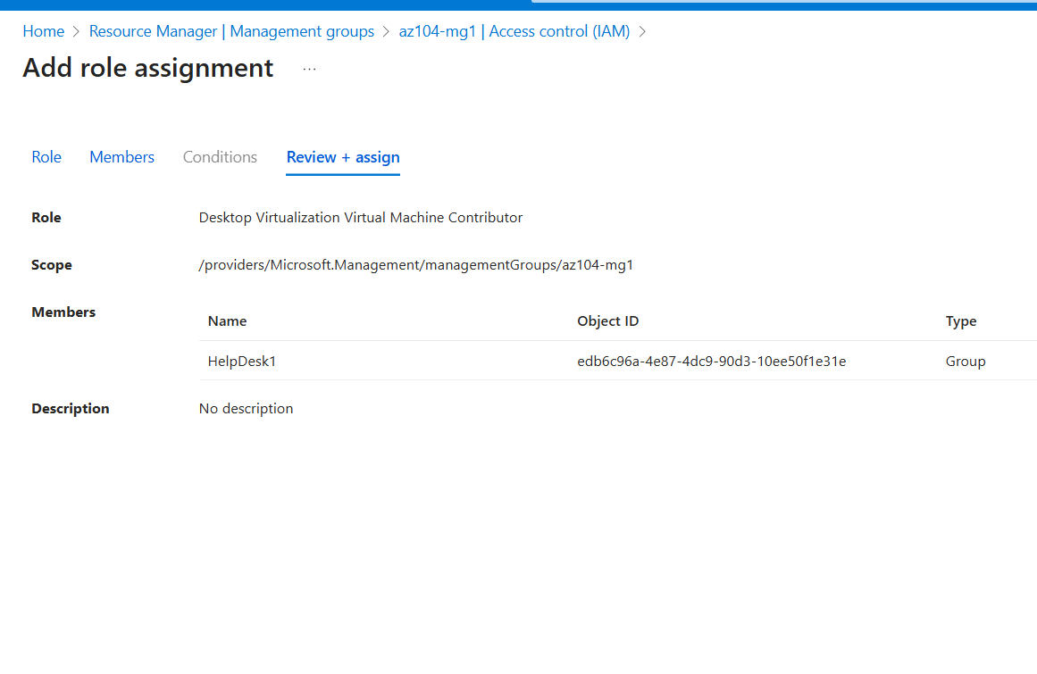

Confirm the assignment under the Role assignments section:
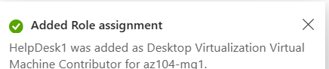
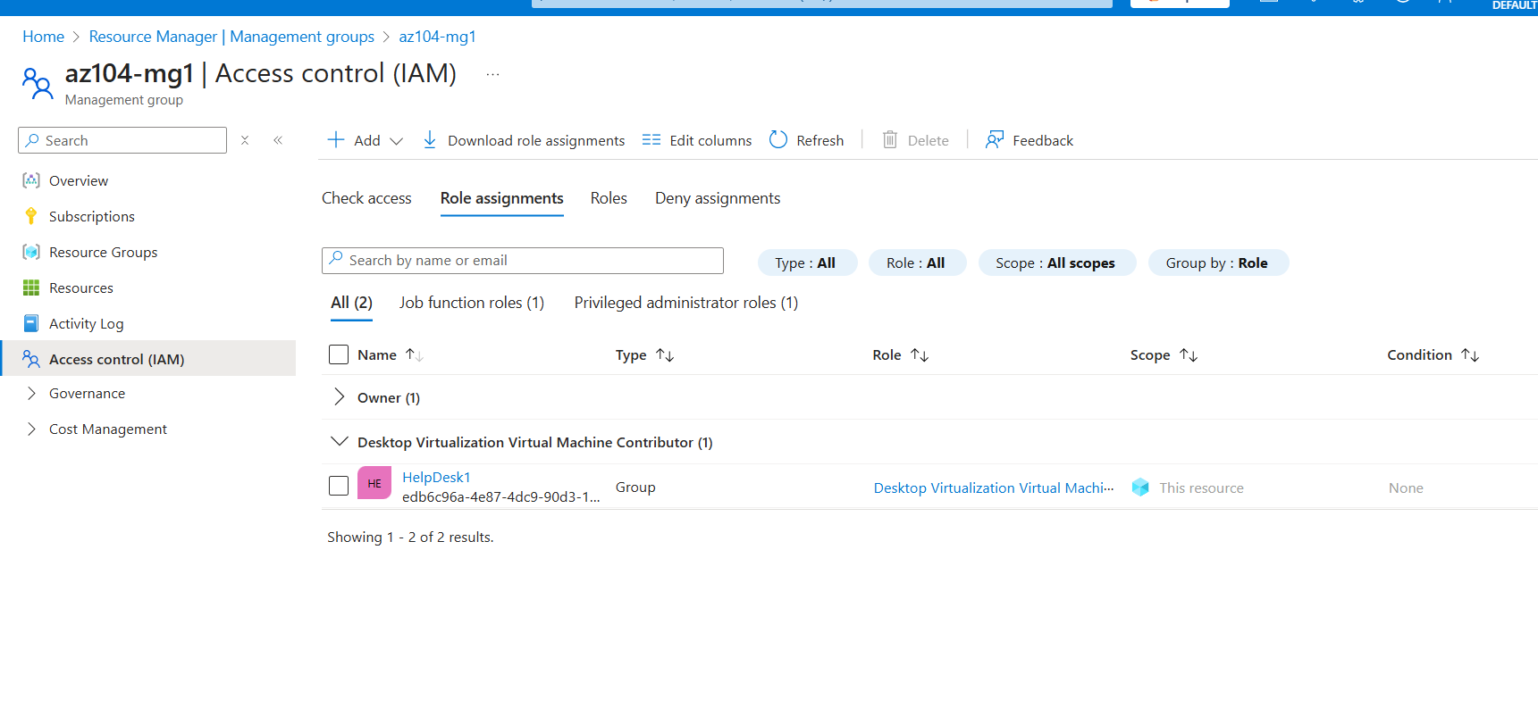

Task 3: Create a Custom RBAC Role
Open the Access control (IAM) blade again.
Select Add → Add custom role.
Clone the Support Request Contributor role
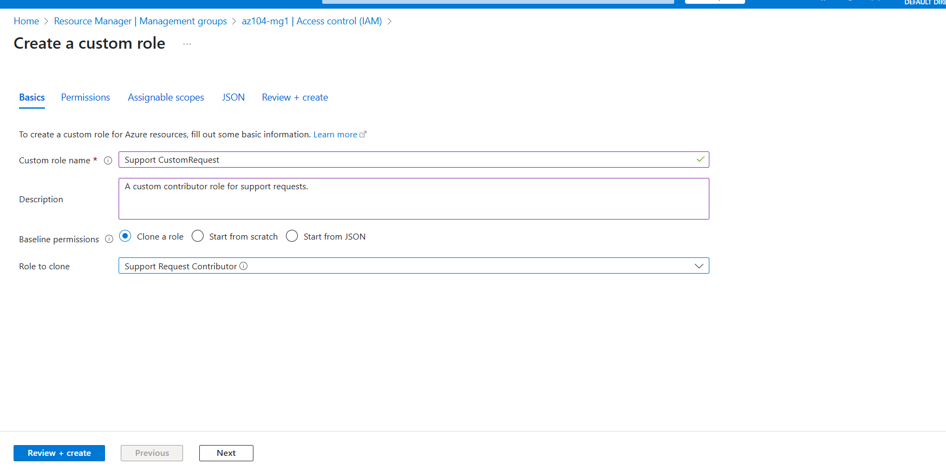
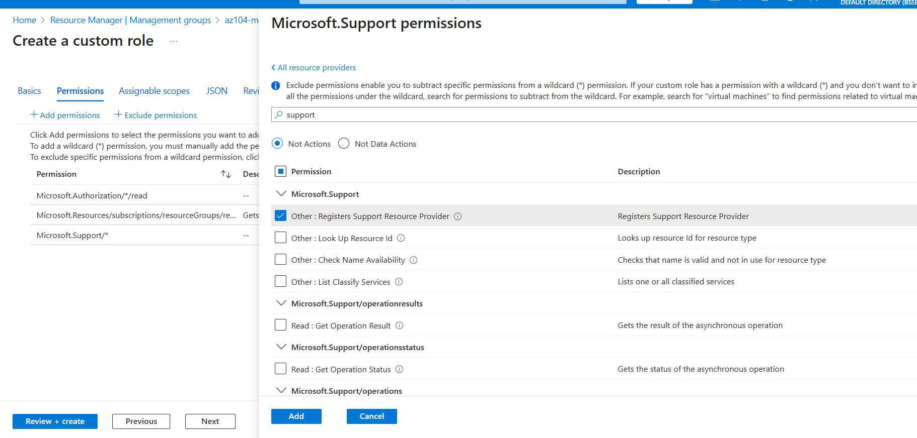
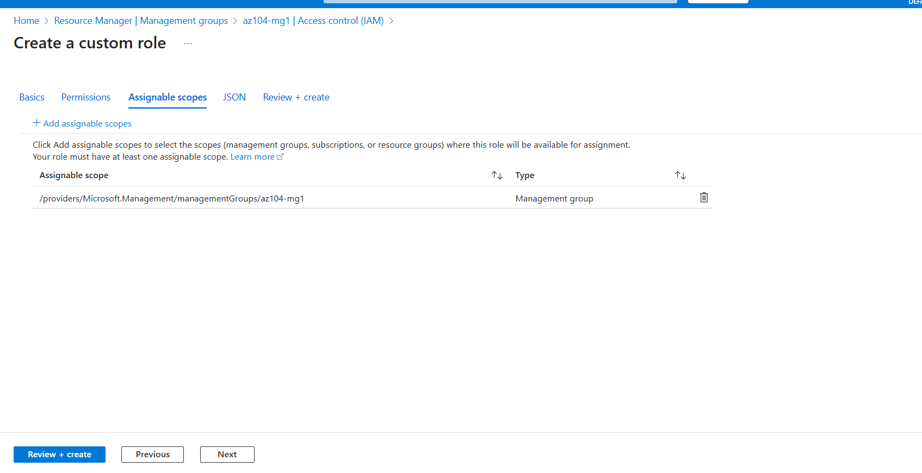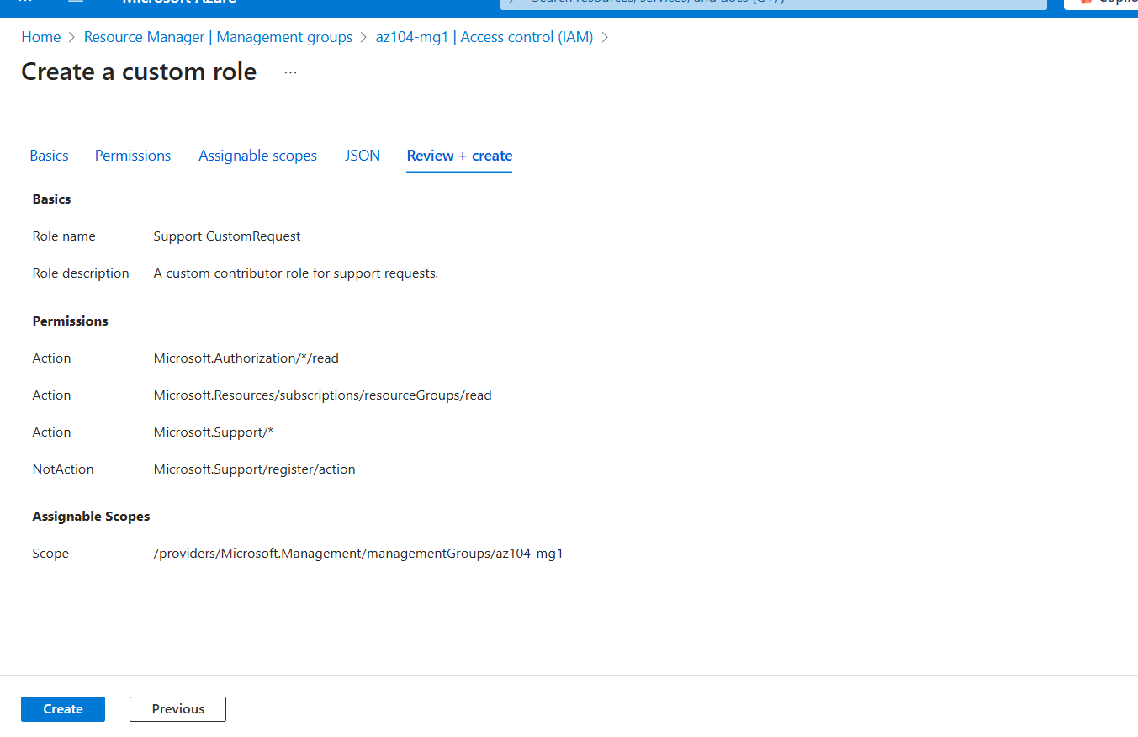
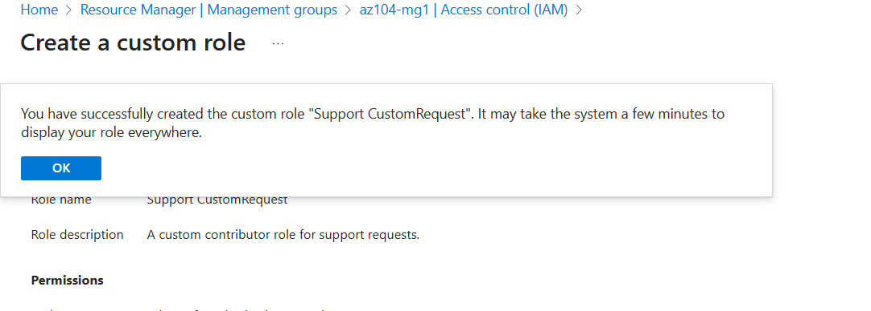

Custom role created successfully:
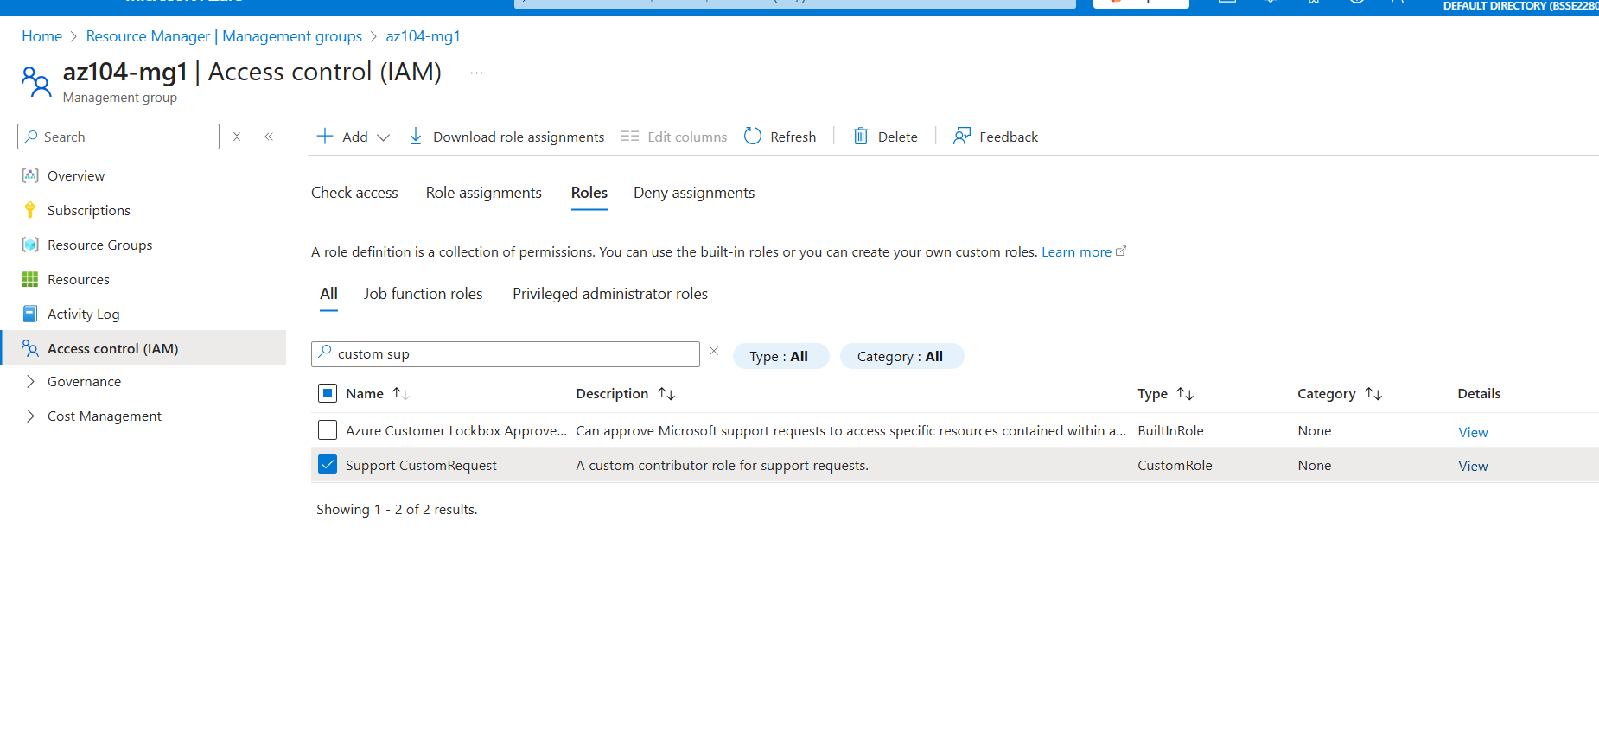

Task 4: Monitor Role Assignments with The Activity Log
In the portal locate the az104-mg1 resource and select Activity log.
